**Cost and Profitability Optimization in Food Delivery: A Case Study Analysis**

**PROBLEM STATEMENT:**

The food delivery service is struggling to achieve profitability, facing challenges across its operations. The company seeks a comprehensive evaluation to optimize cost and profitability, aiming to identify opportunities for cost reduction, revenue enhancement, and the implementation of effective pricing or commission strategies. The analysis will focus on examining all costs associated with delivering food orders, including direct expenses like delivery fees and packaging, as well as indirect expenses like customer discounts and restaurant commission fees. The goal is to provide insights into the service's profitability on a per-order basis and to develop strategies to improve financial performance.

**DATASET:**

With a dataset comprising 1,000 food orders, the food delivery service aims to gain insights into its cost structure and profitability dynamics. This analysis is intended to help the service identify strategic opportunities for improvement.

The dataset contains comprehensive details on food orders,

1. Order ID
2. Customer ID
3. Restaurant ID
4. Order and Delivery Date and Time
5. Order Value
6. Delivery Fee
7. Payment Method
8. Discounts and Offers
9. Commission Fee

10.Payment Processing Fee

11.Refunds/Chargebacks.

This data provides a foundation for analysing the cost structure and profitability of the food delivery service.

**PROCESS:**

The process we can follow for the task of Food Delivery Cost and Profitability Analysis:

1. Start by gathering comprehensive data related to all aspects of food delivery operations.
2. Clean the dataset for inconsistencies, missing values, or irrelevant information.
3. Extract relevant features that could impact cost and profitability.
4. Break down the costs associated with each order, including fixed costs (like packaging) and variable costs (like delivery fees and discounts).
5. Determine the revenue generated from each order, focusing on commission fees and the order value before discounts.
6. For each order, calculate the profit by subtracting the total costs from the revenue. Analyse the distribution of profitability across all orders to identify trends.
7. Based on the cost and profitability analysis, develop strategic recommendations aimed at enhancing profitability.
8. Use the data to simulate the financial impact of proposed changes, such as adjusting discount or commission rates.

**TASK:**

1. **Comprehensive Cost Evaluation:** Identifying the major cost components associated with delivering food orders, including direct costs like delivery fees and indirect costs like discounts and payment processing fees.
2. **Assessment of Profitability**: Calculating the profitability of individual orders and aggregating this data to assess overall profitability. This involves examining how revenue generated from commission fees measures against the total costs.
3. **Strategic Improvement Suggestions:** Based on the cost and profitability analysis, (identifying actionable strategies to reduce costs, adjust pricing, commission fees, and discount strategies to improve profitability.) This includes finding a “sweet spot” for commission and discount percentages that ensures profitability across orders.
4. **Simulation of Strategy Impact:** Simulating the financial impact of the recommended strategies on profitability, using the dataset to forecast **how adjustments in commission rates and discount strategies could potentially transform current losses into profits.**

**OUTCOME:**

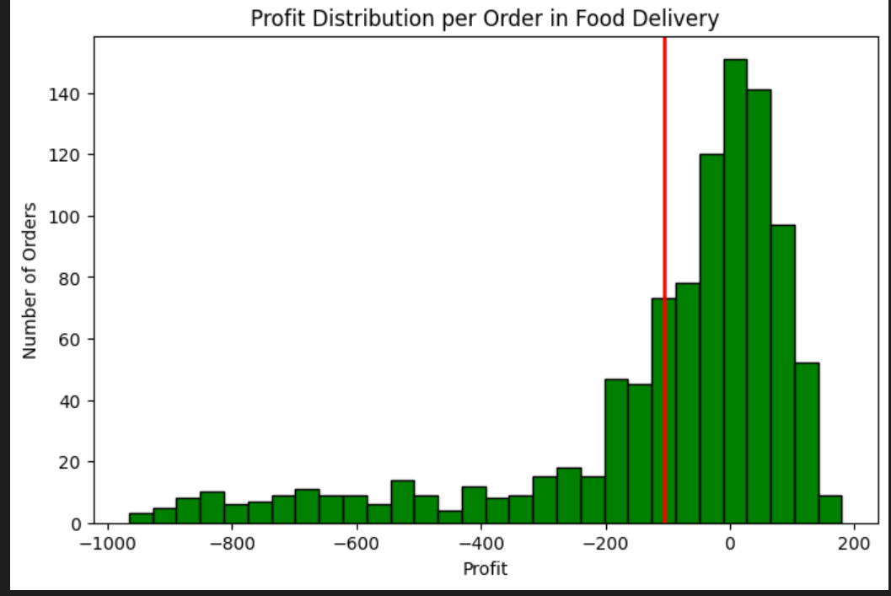

The **histogram** shows a wide distribution of profit per order, with a noticeable number of orders resulting in a loss (profits below 0). The red solid line indicates the average profit, which is in the negative territory, highlighting the overall loss-making situation.

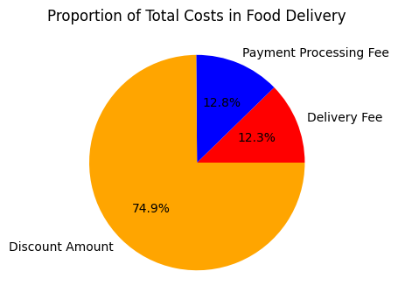

The **pie chart** illustrates the breakdown of total costs into delivery fees, payment processing fees, and discount amounts. Discounts constitute a significant portion of the costs, suggesting that promotional strategies might be heavily impacting overall profitability.

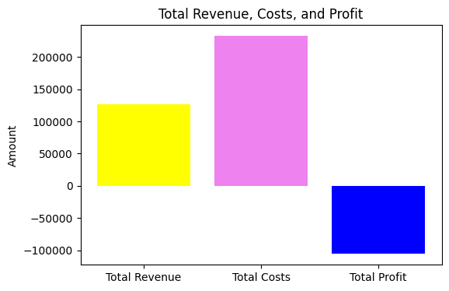

The **bar chart** shows the **total revenue, total costs, and total profit**. It visually represents the gap between revenue and costs. It makes it easy to see that **costs are higher than revenue**, resulting in an overall **loss**.

**A NEW STRATEGY FOR PROFITS:**

From the analysis so far, we understood that the discounts on food orders are resulting in huge losses. Now, we need to find a new strategy for profitability. We need to find a sweet spot for offering discounts and charging commissions. To find a sweet spot for commission and discount percentages, we can analyze the characteristics of profitable orders more deeply. Specifically, we need to look for:

* A new average commission percentage based on profitable orders.
* A new average discount percentage for profitable orders, that could serve as a guideline for what level of discount still allows for profitability.

With these updated averages, we can propose modifications that could enhance the profitability of each order and have a positive impact on overall profitability across all orders.

After analyzing profitable orders, we've identified a revised set of averages for commission and discount percentages that could serve as an optimal balance. The new averages are:

* New Average Commission Percentage: 30.51%
* New Average Discount Percentage: 5.87%

Based on this analysis, a strategy that aims for a commission rate closer to 30% and a discount rate around 6% could potentially improve profitability across the board.

let’s visualize a comparison of profitability using actual versus recommended discounts and commissions across all orders.

* 1. Calculate the profitability per order using the actual discounts and commissions already present in the dataset.
  2. Simulate profitability per order using the recommended discounts (6%) and commissions (30%) to see the potential impact on profitability.

This comparison will help illustrate the potential impact of adopting the recommended discount and commission rates on the overall profitability of orders.

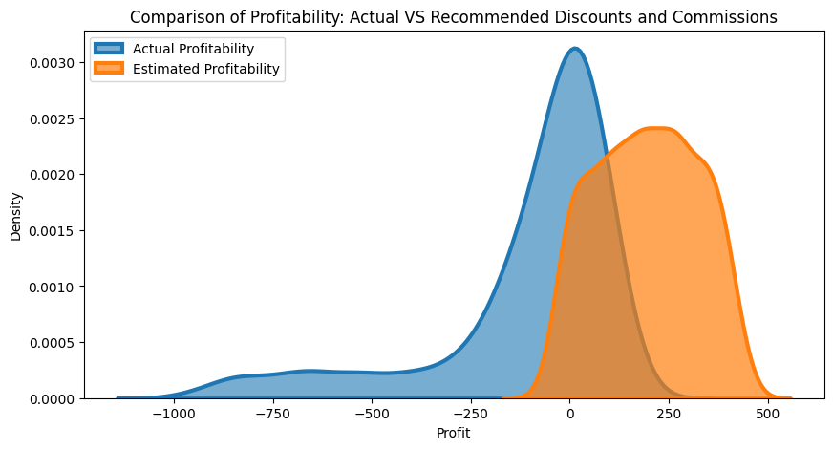

The actual profitability distribution shows a mix, with a significant portion of orders resulting in losses (profit < 0) and a broad spread of profit levels for orders. The simulated scenario suggests a shift towards higher profitability per order. The distribution is more skewed towards positive profit, indicating that the recommended adjustments could lead to a higher proportion of profitable orders.

**SUMMARY:**

Analyzing the cost and profitability of a food delivery company involves a comprehensive examination of all expenses related to delivering food orders. This encompasses direct costs such as delivery fees and packaging, as well as indirect expenses like customer discounts and restaurant commission fees. By comparing these costs against the revenue generated, primarily through order values and commission fees, the analysis aims to provide insights into the service's profitability per order.